**FINAL PROJECT REPORT**

July 2020

**Project ID**: SPS_PRO_1674

**Project Title**: Sentiment Analysis of Covid-19 Tweets – Visualization Dashboard

**Start Date**: 06/08/2020

**End Date**: 07/15/2020

**Project Home Page**: <https://covid-19-ibm.herokuapp.com/>

**INTRODUCTION**

**Overview**

On an average of 3-4 million tweets are shared on Twitter daily from across the country, India. As per the stats of April 2020, India comes eighth in the world with a total number of 13.15 million Twitter users. During this COVID-19 lockdown in India, people have used several social media platforms to express their feelings and share their thoughts with the world.

In this project, we have extracted country-wide, spatial Twitter data, regarding COVID-19, from India, and have analyzed millions of tweets to perform sentiment analysis a.k.a opinion mining to learn about people's sentiments during the pandemic-struck phase. The goal of our sentiment analysis project involved classifying the tweets into 'positive', 'negative', or 'neutral' polarity and presenting the data in a lucid format.

As the project's output, we have developed a sentiment analysis dashboard to visualize the polarity data.

**Purpose**

Today, social media covers a huge part of everyone's life. They are increasingly becoming the platform of communication for every means. Businesses can effectively utilize this by carefully listening and monitoring consumers. To properly understand customer needs, it is imperative to leverage Sentiment Analysis. Also, it can be used proactively to solve many business problems. It can also benefit Health Professionals, Policymakers, State and Central governments, and societal representatives.

**LITERATURE SURVEY**

**Existing Problem**

On 11th March 2020, the World Health Organization announced the COVID19 outbreak as a pandemic. Starting from China, this virus has infected and killed thousands of people from Italy, Spain, the USA, Iran, and other European countries as well. While this pandemic has continued to affect the lives of millions, many countries have resorted to complete lockdown. People started feeling as if they were chained, depression took over therefore, people clung to various social media applications to share their feelings and how did they spend time at home while doing various things and keeping each other's morale up.

**Proposed Solution**

Using various Twitter and Python API's we fetched Tweets from across the country and performed Sentiment Analysis on the Tweets of the people of India to gain a wider public opinion on how the mass was keeping up during this period and then the various government and private organizations can come up with new ideas and products boost up the morale of the public.

We have used VADER (Valence Aware Dictionary and Sentiment Reasoner), a rule-based sentiment analysis tool that is specifically attuned to sentiments expressed in social media. VADER uses a list of lexical features that are generally labeled according to their semantic orientation as either positive or negative or neutral. It has been found successful when dealing with social media texts, editorials, reviews, etc. It not only tells us about positivity or negativity of a text but also tells us about how positive or negative a sentiment is.

**THEORETICAL ANALYSIS**

**Block Diagram**

Dashboard Creation

Data Mining and Collection

Cleaning and Pre-processing the Raw Data

Sentiment Analysis using VADER

Visualization of the processed Data

**Hardware/Software Designing**

The project was built using the following hardware and software specifications:

**Software:**

* Python version 3.8

**Hardware:**

* Memory: 8 GB
* Hard Disk: 1 TB
* Processor: Intel Core i5 7th Gen

**Project Specifications**

The project has been deployed on a Web server so any device that can support a Web browser with HTML5 support will be able to run the app.

**EXPERIMENTAL INVESTIGATIONS**

In the process of developing this Twitter Sentiment Analysis Project we have undergone a lot of brainstorming and explored various new concepts about Natural Language Processing. Experimental Investigations conducted during the process of creating the Project were on the following topics:

* Collection of Historical Twitter Data.
* Choosing the best model to perform Sentiment Analysis on the collected data.
* Gathering Insights from the results of the model and then Visualizations of the Outputs.
* Choosing the best Python Framework to create an app in the lowest possible size.
* Choosing the best and most dynamic platform to deploy our Visualization Dashboard.

**FLOWCHART**

**RESULT**

**Dashboard**

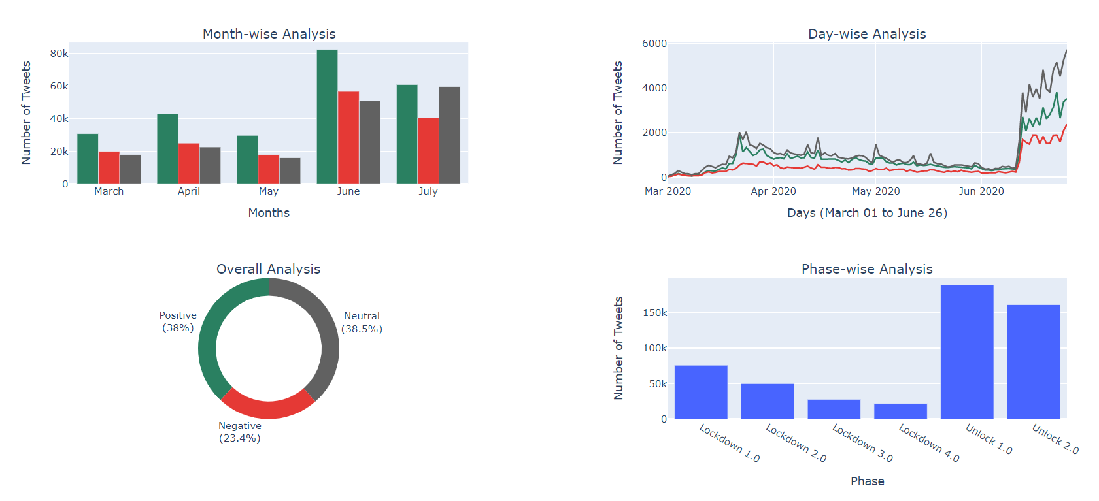

**Sidebars**

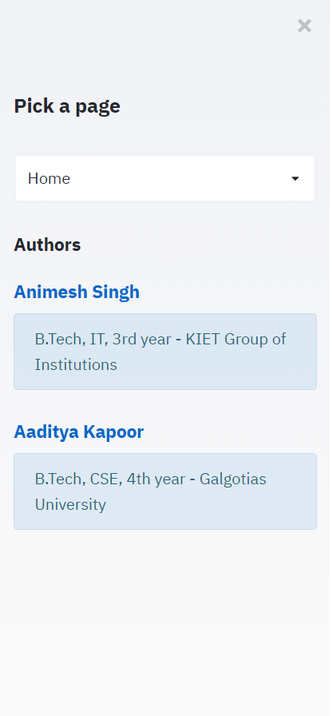

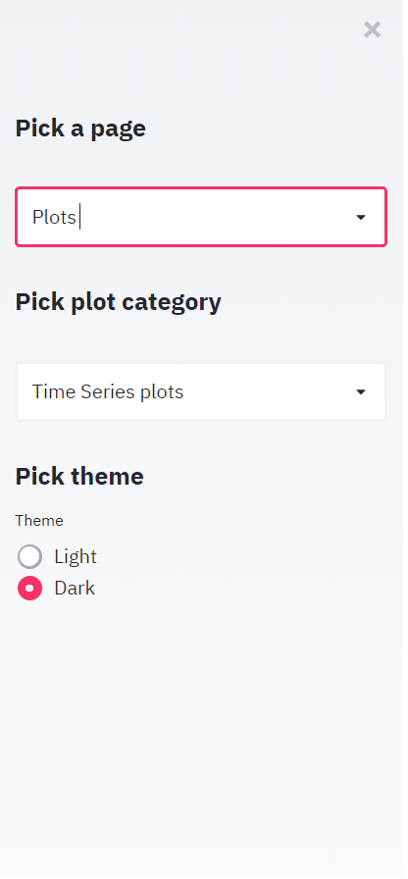

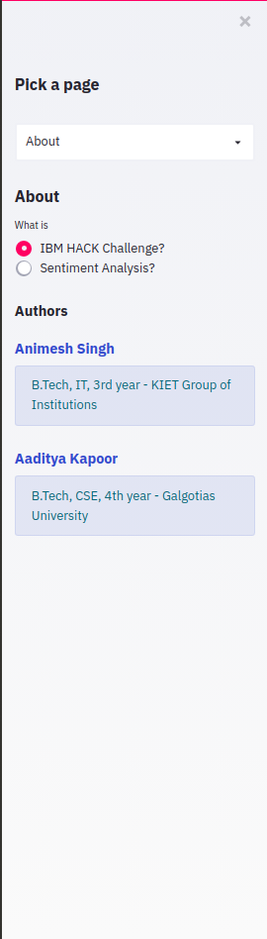

**Graphs**

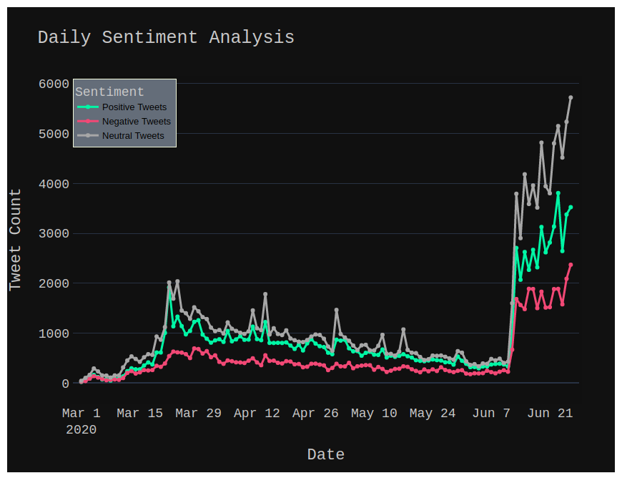

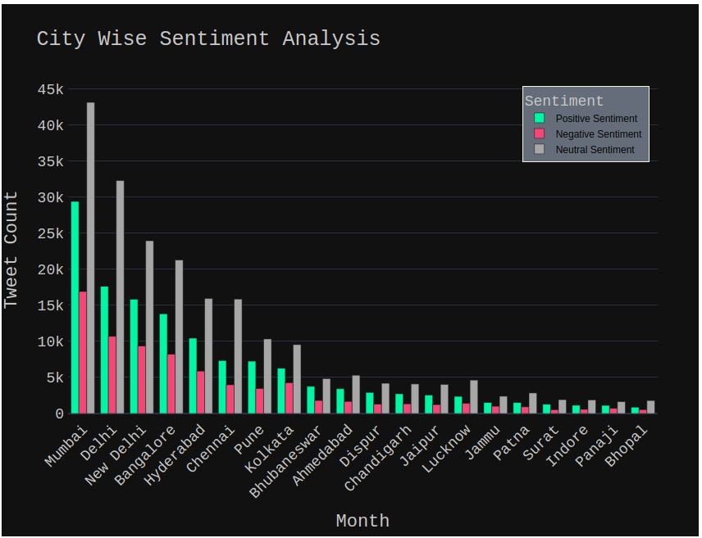

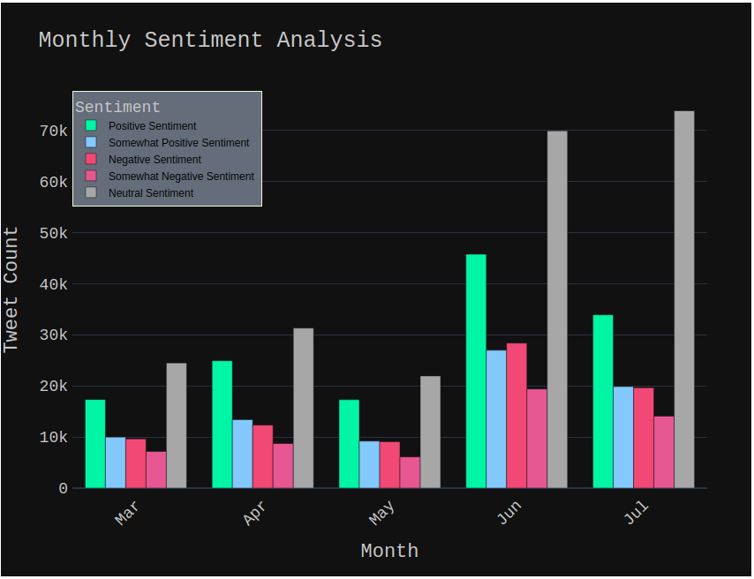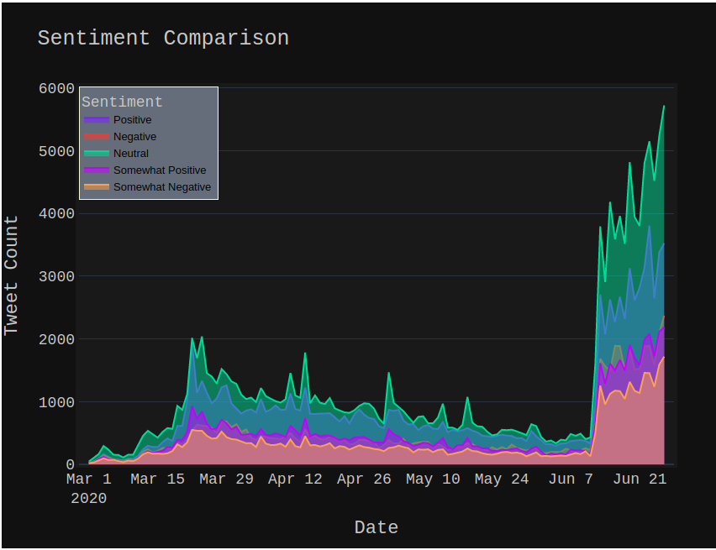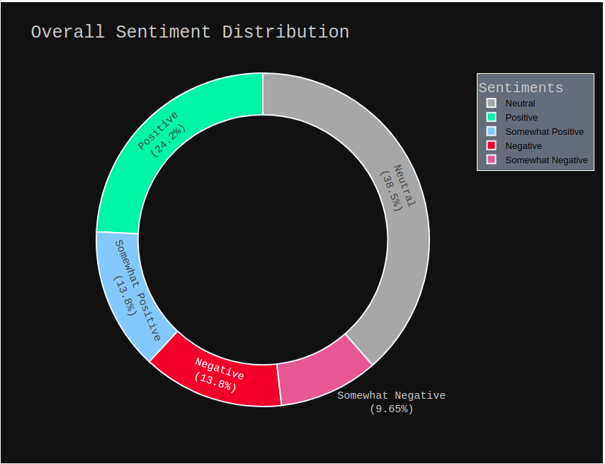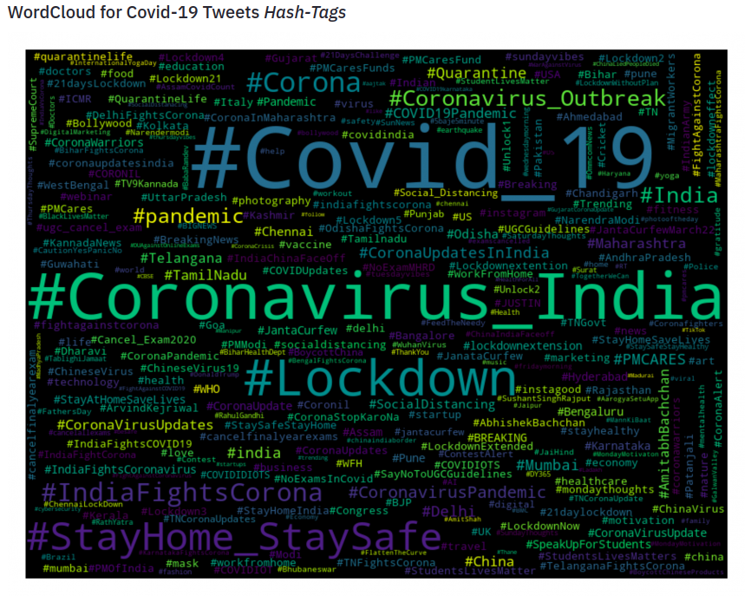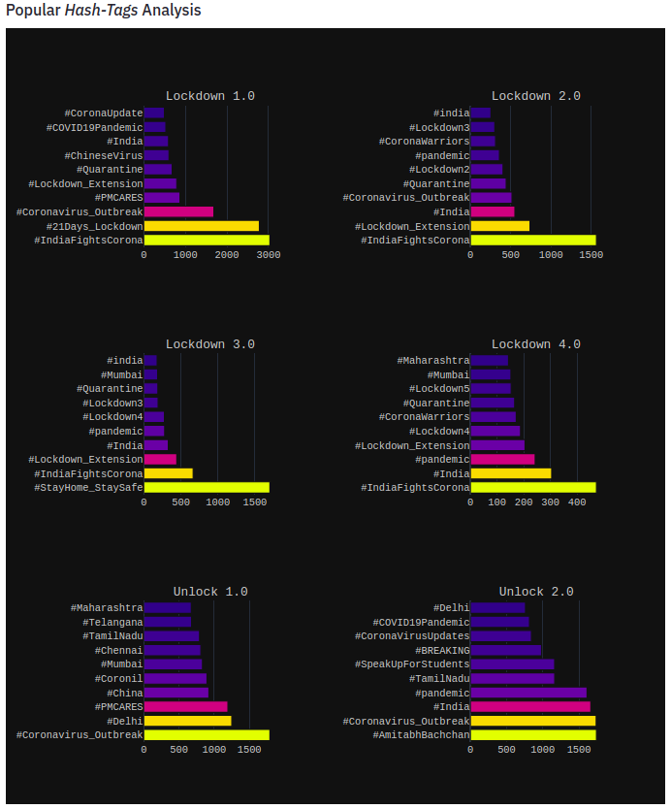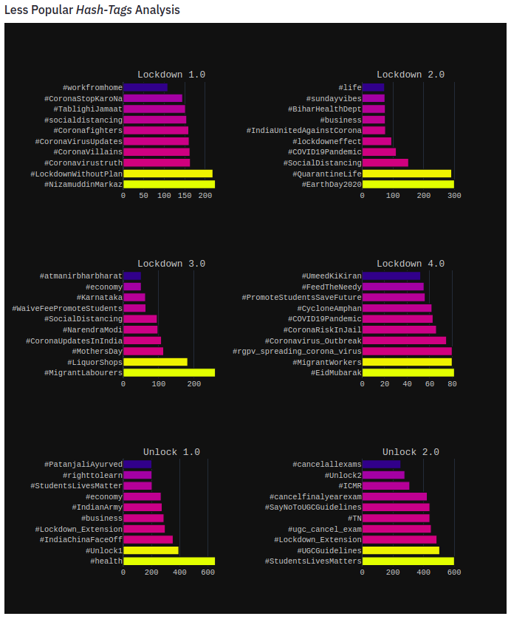

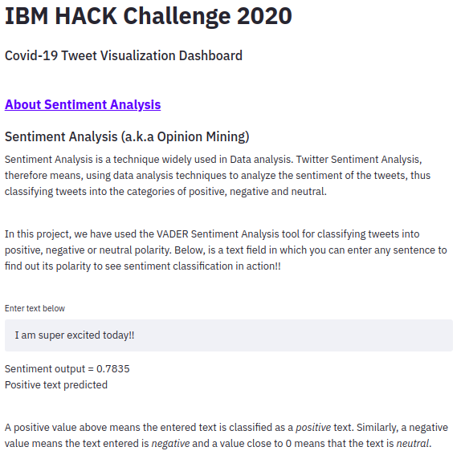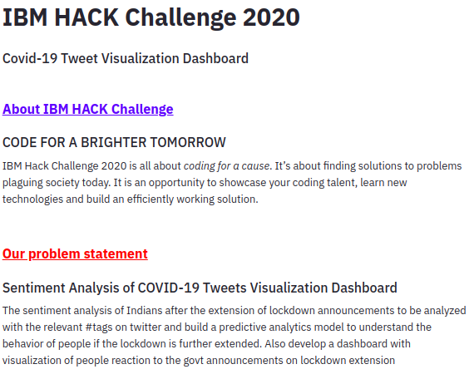

**ADVANTAGES & DISADVANTAGES**

Some Advantages:

* **Works exceedingly well on social media** type text such as public opinion.
* Doesn’t require any training data but is constructed from a generalizable, valence-based, human-curated gold standard sentiment lexicon.
* **Fast** enough to be used online with streaming data.
* Does not severely suffer from a **speed-performance trade-off**.
* **Efficient** at analysing large datasets.
* Can identify whether a phrase is positive, negative or neutral, which in turn can be used to determine a customer’s sentiment towards a brand or service. This helps the businesses to identify their strengths and weaknesses.
* It can also help to identify marketing campaigns that are not working well.

Some disadvantages:

* Spellings and grammatical mistakes may cause the analysis to overlook important words or usage.
* Sarcasm and irony may be misinterpreted.
* Analysis is language-specific.
* Discriminating jargon, nomenclature, memes, or turns of phrase may not be recognized.
* Unavailability of Twitter Historical Data.

**APPLICATIONS**

This automated machine learning driven sentiment analysis could help the following people and industries:

* Health Professionals.
* Policy makers.
* State and Central Governments to understand and identify rapidly changing psychological risks in the population.
* Timely responses and initiatives taken by the agencies to mitigate and prevent adverse emotional and psychological consequences will significantly improve public crisis and phenomenon.
* Provide valuable insights on attitudes, perceptions and behaviours for critical decision making for business, political leaders and societal representatives.
* Corporations and small businesses can also benefit through such analyses and machine learning models to better understand consumer sentiment and expectations.

**CONCLUSION**

This project deals with the sentiment analysis of Indians a few days before and after the lockdown announcements were made. We used the social media platform Twitter for our analysis. Tweets were studied to gauge the feelings of Indians towards the lockdown. Tweets were extracted using the following prominent hashtags namely: #COVID, #Coronavirus, #Lockdown, #Pandemic, and #PMCares from March 1st to July 10th, 2020. A total of 5, 74,108 tweets were considered for the analysis. The analysis was done using Python and different graphs were generated that depicts the sentiments of the tweets.

Overall, it can be seen that Indians have taken the fight against COVID19 positively and the majority are in agreement with the government for announcing the lockdown to flatten the curve. It could be seen from the tweets that several people were angry that the lockdown came a bit late. It should have been announced a week prior. Also, some tweets expressed concerns that the passengers from abroad who flew in should have been quarantined before letting them reunite with their families. Nevertheless, as of now, the lockdown response seems positive and indicates that India has succeeded in controlling the coronavirus spread to a great extent.

**FUTURE SCOPE**

Future studies can look into pre and post lockdown tweets and understand whether there was a change in sentiments from the beginning to the end of the lockdown. Also, future studies can look into factors that affect mental health during lockdowns and pandemic spreads. Another area for future research could be tackling of fake news that gets circulated through social media, impacting the mental health of the receivers. Many private and public industries can also research to create products for the post lockdown situation of the country

**BIBLOGRAPHY**

**Names:** Animesh Singh and Aaditya Kapoor

**College Names:** KIET Group of Institutions and Galgotias University

**Work Title:** Sentiment Analysis of Covid-19 Tweets – Visualization Dashboard

**References:**

**Research and Feasibility Study for Twitter Sentiment Analysis**

* <https://www.saifmohammad.com/WebDocs/emotion-survey.pdf>
* <https://github.com/abdulfatir/twitter-sentiment-analysis>
* <https://github.com/cjhutto/vaderSentiment>
* <https://github.com/sloria/textblob>
* <https://cloud.ibm.com/apidocs/tone-analyzer?code=python>
* <https://medium.com/@Intellica.AI/vader-ibm-watson-or-textblob-which-is-better-for-unsupervised-sentiment-analysis-db4143a39445>
* <https://towardsdatascience.com/twitter-sentiment-analysis-based-on-news-topics-during-covid-19-c3d738005b55>
* <https://python.gotrained.com/tf-idf-twitter-sentiment-analysis/>
* <https://www.kaggle.com/satanizer/covid-19-tweets-analysis>

**Gathered Twitter Data using this Python Library**

* <https://github.com/Jefferson-Henrique/GetOldTweets-python>
* <https://github.com/Mottl/GetOldTweets3>

**Python Libraries and Frameworks used**

* <https://pypi.org/project/vaderSentiment/>
* <https://plotly.com/python/getting-started/#:~:text=Plotly%20in%20Python-,Overview,the%20Plotly%20JavaScript%20library%20(plotly.>
* <https://pypi.org/project/pydeck/>

**Python Dynamic App Creation**

* <https://www.streamlit.io/>

**Deployment Platform**

* <https://www.heroku.com/>

**APPENDIX**

**Source Code**

**Data Extraction**

# Importing Python Libraries

from datetime import date, timedelta

import GetOldTweets3 as got

import time

import pandas as pd

# Start and End Date for Data Extraction

sdate = date(2020, 6, 26)

edate = date(2020, 6, 27)

delta = edate – sdate

# Cities of which Data has been Collected

cities1 = ['Mumbai', 'Delhi', 'Bangalore', 'Chennai', 'Kolkata', 'Ahmedabad', 'Jaipur', 'Chandigarh', 'Lucknow', 'Varanasi', 'Panaji', 'Jammu', 'Gandhinagar', 'Gangtok', 'Aizawl', 'Amravati', 'Itanagar', 'Dispur', 'Patna', 'Shimla', 'Ranchi', 'Bengaluru', 'Thiruvananthapuram', 'Surat', 'Jodhpur', 'Bhopal', 'Indore', 'Pune', 'Imphal', 'Bhubaneswar', 'Hyderabad', 'Mysore', 'Dehradun', 'Port Blair']

cities2 = ['Daman & Diu','Raipur','New Delhi','Lakshadweep','Shillong','Kohima','Agartala','Pondicherry', 'Amritsar']

# Data Extraction has been done using these Hashtags

tags = ['covid','coronavirus','lockdown','pandemic','PMcares']

cities = cities1+cities2

error_dates = []

error_cities = []

error_tags = []

tweet_data = []

for i in range(0, delta.days + 1,1):

day_s = str(sdate + timedelta(days=i))

day_e = str(sdate + timedelta(days=i+1))

for tag in tags:

for city in cities:

tweetCriteria = got.manager.TweetCriteria().setQuerySearch(tag)\

.setSince(day_s)\

.setUntil(day_e)\

.setNear(city)

# **TRY CATCH BLOCK** to avoid any kind of errors while extracting data

try:

print("Searching for tweets...\tCity-> {}\tDate-> From {} to {}".format(city, day_s, day_e))

tweets = got.manager.TweetManager.getTweets(tweetCriteria)

print("Search complete!!")

except:

print("\n\nError occurred..Going to sleep for 14 minutes.")

error_dates.append([day_s, day_e])

error_cities.append(city)

error_tags.append(tag)

# Sleeping for 10 minutes to reset limit

time.sleep(14*60)

print("\n\nWaking up..\t*yawn*")

# Skipping this iteration to avoid storing redundant tweets

# in tweet_data

continue

for tweet in tweets:

tweet_data.append([tweet.text,tweet.date,tweet.retweets,tweet.favorites,tweet.hashtags,city])

print("Data saved!")

print("\n\nTweets so far: {}".format(len(tweet_data)))

if len(error_cities) > 0:

print("\n\nNOTE: Tweets were missed for: {} cities on these dates: {}".format(error_cities, error_dates))

else:

print("No errors occurred during execution.Proceed to creating a dataframe and save it in your drive!")

print("Making dataframe..")

df = pd.DataFrame(tweet_data, columns=['Text', 'Date', 'Retweets', 'Favs', 'Hashtags', 'City'])

print("Exporting dataframe..")

df.to_csv('Tweets from '+str(sdate)+' to '+day_e+'.csv')

print("Data exported successfully!")

**Cleaning and Preprocessing**

import re # Importing Regular Expressions

# Function to **remove URLS**

def remove_urls(df, column_name):

# This will remove all the urls from the tweets

df[column_name] = df[column_name].apply(lambda x : "".join(re.sub(r'((www\.[\S]+)|(https?://[\S]+))', '', x)))

return df

# Function to **remove Mentions**

def remove_mentions(df, column_name):

# This will remove mentions (e.g. @elon_musk, @animesh983881 etc) from the tweets

df[column_name] = df[column_name].apply(lambda x : "".join(re.sub(r'@[\S]+', '', x)))

return df

# Function to **remove Retweets**

def remove_RT(df, column_name):

# A lot of tweets will contain retweet information as RT as a tweet's prefix

# Since, the tweets are all already converted to lower case, we are replacing 'rt' and not 'RT'

df[column_name] = df[column_name].apply(lambda x : "".join(re.sub(r'\brt\b', '', x)))

return df

**Sentiment Analysis**

# Importing VADER

from vaderSentiment.vaderSentiment import SentimentIntensityAnalyzer

sa_object = SentimentIntensityAnalyzer()

scores = []

for text in df['Text']:

score = sa_object.polarity_scores(text)['compound']

scores.append(score)